The 7th International Symposium on Frontiers in Ambient and Mobile Systems (FAMS 2017)

The analysis of advantages and disadvantages of use of social media in European Union

**Abstract**

Social media is a platform that we use every day and spend much time on them. Therefore, it is necessary to know the basic information about the advantages and disadvantages of using social media. Our research deals with social media and their perception of the general public. We examined by the survey which social media people use, for what purpose they are used and how they perceive the positive and negative aspects of using social media. After analyzing the survey results, we've identified the three most used social media in the European Union and the opinion of social media users on the advantages and disadvantages associated with their use.

# Introduction

Social media are very often lately dissolving theme and also have great popularity among users. Therefore, it is interesting to address the issue of the perception of their social media users. Our research is focused on the specific use of social media and the perception of the advantages and disadvantages of their use by respondents.

In our paper, we are presenting the results of data surveyed from 275 respondents from European Union including: structure of utilization of social media, for what purpose they are used and how they perceive the positive and negative aspects of using social media.

* 1. *Web 2.0 and Social Media*

The term Web 2.0 describes trends and ways in which the web will probably take. However, someone argue that Web 2.0 is just a bubble - marketing term created how to amaze and gain customers with something that does not exist. The second on the other hand see new quality and others say that Web 2.0 = social media. 1

Social media have revolutionized the use of Internet as a tool to propagate products and promote their sale. Opens the possibility of less expensive and more effective online marketing and also offer new approaches to direct contact with potential customers, inspire in developing business and communication strategy.

Every day millions of users publish their articles, photos and videos with the help of services such as YouTube, Flickr, Wordpress and share them with others. The phenomenon of user-generated content got into the center stage approximately in 2005 with the arrival of so-called waves of Web 2.0. Many experts led by Tim O'Reilly pointed to the rising trend of involving the user directly to the creation of the site. Thus formed web has become more targeted and more useful. As best seen on sites that are now symbols of social media: Facebook (* 2004), YouTube (* 2005) and Twitter (* 2006). Probably with the best definition came Andreas Kaplan and Michael Haenlein who identified social media as "a group of Internet applications built on the ideological and technological foundations of Web 2.0 that allow the creation and exchange of user-generated content." 2

Social media allow people to exchange ideas and opinions, discuss together the content of pages and make contacts online. 3 Social media is different from traditional mainstream media in that their content can create everybody as well contribute into it or comment on it. 4 They may have a text format, may be an audio, video or photographs and other visual forms that bring together communities, and assist people who want to associate together. 5

To make it easier to understand them, it is important to note that there are two terms that sound similar, and many people are confused about them, they are: social media and social networks. The term social media is superior to the social networks and includes various media that people use for online communication and collaboration and also to develop social interaction (sociability). Social media include blogs, wikis, video or photo sharing sites and more other things.

Creating social networks belongs under the social media and the term is used when it is some way of people interaction, such as Facebook, LinkedIn, MySpace and so on. We are talking about creating social networks when people create personal profiles and interact with the aim of becoming part of a community of friends and people who have "the same blood type," that are interested to communicate and exchange information.

# Results

In our paper, we are presenting the results of data surveyed from 275 respondents from European Union including: structure of utilization of Web 2.0, risks and their perception by respondents and general principles of security.

Subsequently, after analyzing of this data we have managed the design of specific recommendations for safety using of social media.

* 1. *The most used platforms of Web 2.0*

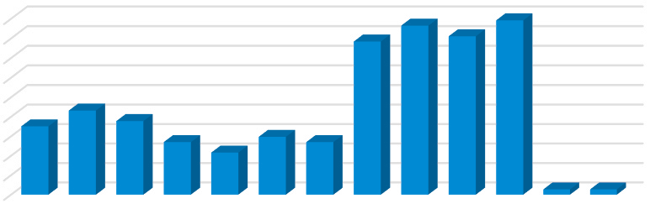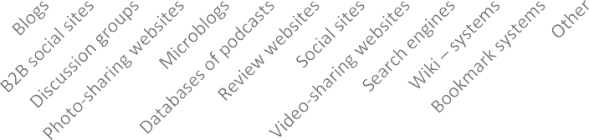

The most used platforms of Web 2.0

89,20%

90,00%

80,00%

70,00%

60,00%

50,00%

40,00%

30,00%

20,00%

10,00%

0,00%

78,40%

86,50%

81,10%

35,10%

43,20%

37,80%

27%

21,60%

29,70%

27%

2,70%2,70%

Fig. 1. The most used platforms of Web 2.0

From Graph 2 below it can be seen that the most widely used Web 2.0 in the EU are wiki-systems with 89.2%, the second most widely used Web 2.0 to Web sites for sharing videos with 86.5%, followed by the search engine with

81.1 % of respondents.

Despite the fact that the results vary by region, the three most widely used Web 2.0 social networks, video sharing sites, search engines and fourth in their follow-wiki systems.

* 1. *The Use Social Media in European Union*

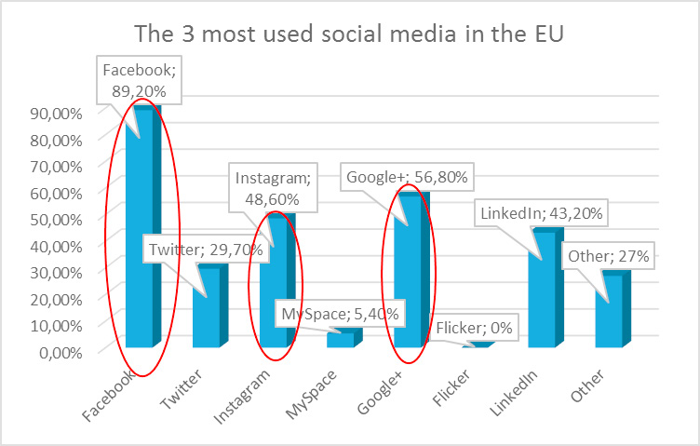In the first part of the questionnaire survey we investigated in the users' social media which ones are used and for what purpose. Here we wanted to find out extent of the use of social media in this area, based on which we would like to identify the most used social media.

Fig. 2. The Three Most Used Social Media in European Union

The most used Web 2.0 platforms in the European Union (89.2%) is the social networking site Facebook. The second most used Web 2.0 has become Google+, in the EU use it to 56.8% of respondents. The third most widely used Web 2.0 application is Instagram, in the EU it is used by 48.6% of respondents.

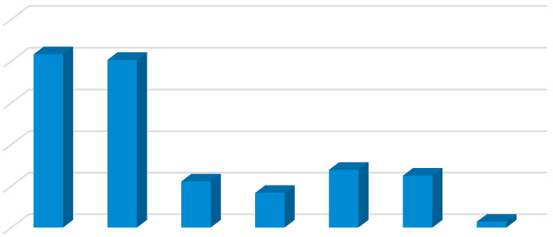

The purpose of using of Web 2.0 platforms

Obtaining of

Contact with

100,00%friends; 83,30%

80,00%

information;

80,60%

60,00%

Monitoring of

messages;

Sale of

products;

40,00%

Online

marketing; 25%

20,00%

22,20%Acquisition and

search for new

friends; 16,70%

27,80%

Other; 2,80%

0,00%

Fig. 3. The Purpose of Using of Web 2.0 Platforms

In the next question participants were asked to what purpose they use platforms of Web 2.0. In the EU they are most used to the contact with friends (83.3%) and the acquisition of information (80.6%) of respondents.

* 1. *Advantages of social media*

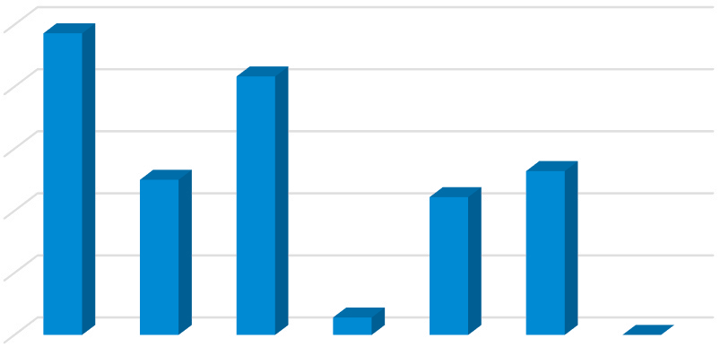

Advantages of social media

Exchange of information and communication; 97,20%

100,00%

Data sharing;

83,30%

80,00%

Teamwork and

working from

home; 50%

Education;

52,80%

60,00%

Services; 44,40%

40,00%

20,00%

Other; 0%

0,00%

Sharing hardware and peripherals; 5,60%

Fig. 4. Advantages of Social Media

On the chart, you can see the benefits of Web 2.0 platforms respondents perceive and which are most important to them. The biggest advantage associated with the use of Web platforms 2 are not as exchange of information and communication. This possibility is said to 97,7% of respondents from EU countries.

The second biggest advantage is the sharing of data by the respondents. In the EU said this option to 83.3% of respondents.

* 1. *Disadvantages of social media*

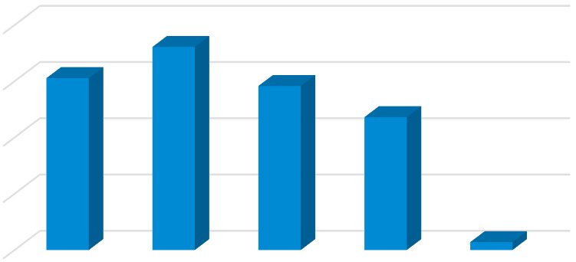

Disadvantages of social media

Internet addiction; 72,20%

80,00%Lack of security;

61,10%

Information

overload; 58,30%

60,00%

Loss of social

contacts; 47,20%

40,00%

20,00%

Other; 2,80%

0,00%

Fig. 5. Disadvantages of Social Media

The biggest drawback, according to all respondents is Internet addiction. This claim 72.2% of respondents from the EU countries.

It is followed by lack of security (61.1%), information overload (58.3%) and loss of social contacts (47.2%).

# Conclusion

Following research in in the literature, we have identified several advantages of social media. These include information exchange and communication, teamwork and work from home, data sharing, sharing hardware and peripherals, services and education.

Advantages of social media, we offered respondents a choice perceived as follows. These are the most important to them. The biggest advantage associated with the use of social media is exchange of information and communication. This marked as a biggest advantage to 97.7% of respondents surveyed in EU countries.

The second biggest advantage by the respondents is sharing of data. In EU countries said it 83,3% of respondents. Disadvantages or threats to which participants were asked, we have identified a survey in the literature dealing with this issue. From the large number of disadvantages of using social media, we selected the following, we offered as a choice for respondents. These include lack of security, internet addiction, information overload, loss of social contacts.

The biggest disadvantage by 72.2% of respondents from EU's internet addiction. It is followed by lack of security, information overload and loss of social contacts.

Another disadvantage of using social media is as follows. For example, a major drawback is the increased percentage of time spent on social media.

# References

1. Janouch V. (2011) Internetový marketing. Prosaďte se na webu a sociálních sítích. Brno: Computer Press, a. s., 304 s. ISBN 978-80-251-2795- 7.
2. Murár P. (2011) Marketing na Twitteri. Bratislava: WebSupport. 133 s. ISBN 978-80-970814-8.
3. Cachia R. (2008) Social Computing: Study on the Use and Impactof Online Social Networking [online]. Luxemburg: European Communities, [cit. 2016-20 – 03]. Dostupné na internete: <<http://publications.jrc.ec.europa.eu/repository/bitstream/111111111/6952/1/jrc48650.pdf>>.
4. Jantsch, J. (2010) Let’s talk. Social Media for Small Business. In ducttapemarketing.com [online]. [cit. 2014 – 14 – 11]. Dostupné na internete:

< <http://www.ducttapemarketing.com/socialmediaforbusiness.pdf>>

1. Scott, D. M. Nové pravidlá marketingu a PR. Ako efektívne využívať sociálne siete a médiá, blogy, správy, online video a virálny marketing na získavanie zákazníkov. Bratislava: Easton Books. 2010. 257 s. ISBN 978-80-8109-149-0.